**Assignment 3**

Name :- Bibek Chand Sah

Roll No. :- 22054029

Section :- CSE-05

1. Create a tabme emp12, with attributes empid, empname, phno, age, and emp_country. Make emp id the primary key of the table. Make empname not null, phno unique and put a check constraint on age which make sure employees are not below 18. Put a default value “India” on emp_country.

🡺 CREATE TABLE emp12 (empid INT CONSTRAINT empid_pk PRIMARY KEY, empname VARCHAR(10) CONSTRAINT empname_nn NOT NULL, phno VARCHAR(10) CONSTRAINT phno_uk UNIQUE, age INT CONSTRAINT age_ck CHECK (age >= 18), emp_country VARCHAR(10) DEFAULT 'India' );

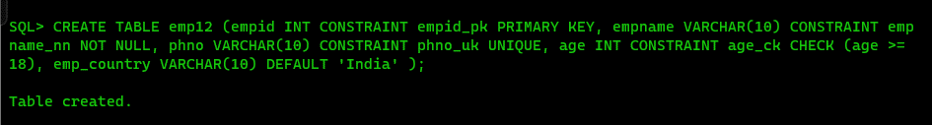

2. Insert the following tuples into emp12 table.

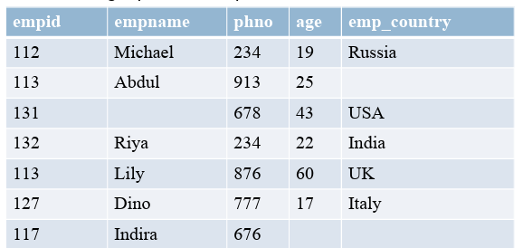

🡺 INSERT INTO emp12 VALUES (&empid, '&empname', '&phno', &age, '&emp_country');

ALTER TABLE emp12 DROP CONSTRAINT empname_nn;

ALTER TABLE emp12 DROP CONSTRAINT phno_uk;

ALTER TABLE emp12 DROP CONSTRAINT empid_pk;

ALTER TABLE emp12 DROP CONSTRAINT age_ck;

3. Drop the check constraint on age.

🡺 ALTER TABLE emp12 DROP CONSTRAINT age_ck;

4. Put a default constraint with value 18 on age along with a check constraint which ensures age value is greater than or equal to 18 and less than or equal to 70.

🡺 ALTER TABLE emp12 ADD CONSTRAINT age_ck CHECK (age >= 18 AND age <= 70) NOVALIDATE;

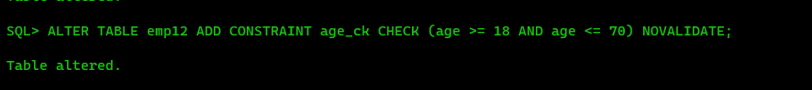

5. Insert the following rows in the emp12 table.

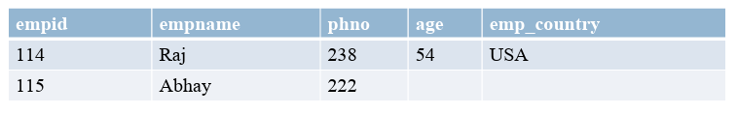🡺 INSERT INTO emp12 VALUES (&empid, '&empname', '&phno', &age, '&emp_country');

6. Create table projectx with attributes pid, pname, phead, ploc and pmembers. pmembers should have a default value of 5. Make (pid,pname) the primary key. Use a constraint named uc_px_34 to make phead and ploc unique. Put a check constraint named ck_px_5 on pmembers which ensures that the number of pmembers must not exceed 5.

🡺 CREATE TABLE projectx ( pid INT, pname VARCHAR(50), phead VARCHAR(50), ploc VARCHAR(50), pmembers INT DEFAULT 5, CONSTRAINT pk_projectx PRIMARY KEY (pid, pname), CONSTRAINT uc_px_34 UNIQUE (phead, ploc), CONSTRAINT ck_px_5 CHECK (pmembers <= 5) );

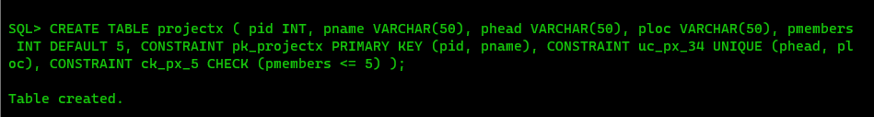

7. Drop the primary key of the projectx table.

🡺 ALTER TABLE projectx DROP CONSTRAINT pk_projectx;

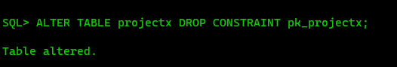

8. Put a constraint named pk_px_1 on pid, making pid the primary key of the table.

🡺 ALTER TABLE project DROP CONSTRAINT pk_projectx;

ALTER TABLE projectx ADD CONSTRAINT pk_px_1 PRIMARY KEY (pid);



9. Insert the following rows in projectx table.

🡺 ALTER TABLE projectx MODIFY pid varchar2(10);

INSERT INTO projectx VALUES ('&pid', '&pname', '&phead', '&ploc', &pmembers);

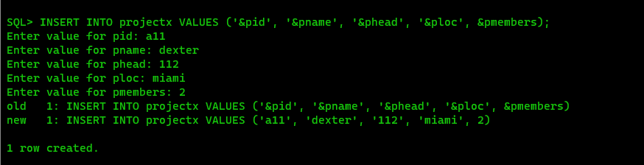

10. Delete all rows from emp12 table except the rows having primary keys (112, 113, 114).

🡺 DELETE FROM emp12 WHERE empid NOT IN (112, 113, 114);

11. Insert a colunm named project in the emp12 table.

🡺 ALTER TABLE emp12 ADD project VARCHAR(10);

12. Update the table as following.

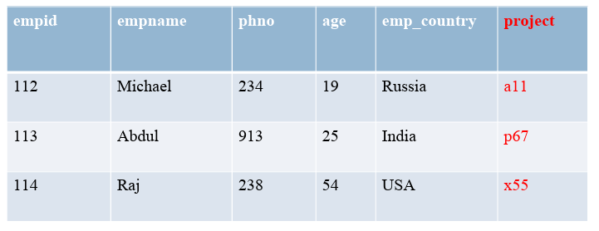

🡺 INSERT INTO emp12 VALUES (&empid, '&empname', '&phno', &age, '&emp_country', '&project');

13. Make the project attribute of the emp12 table a foreign key that links it to the pid attribute of the projectx table.

🡺 ALTER TABLE emp12 ADD CONSTRAINT fk_emp12_project FOREIGN KEY (project) REFERENCES projectx(pid);



14. Insert the following tuples in the emp12 table.

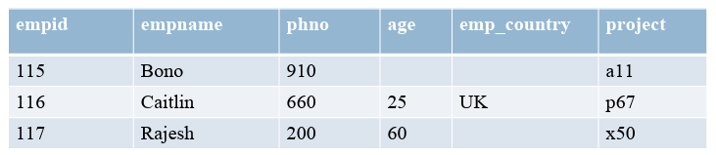

🡺 INSERT INTO emp12 VALUES (&empid, '&empname', '&phno', &age, '&emp_country', '&project');

ALTER TABLE emp12 DROP CONSTRAINT FK_EMP12_PROJECT;

15. Make the phead attribute of the projectx table a foreign key that links it to the empid attribute of the emp12 table.

🡺 ALTER TABLE project ADD CONSTRAINT fk_projectx_emp12 FOREIGN KEY (phead) REFERENCES emp12(empid);

ADD CONSTRAINT CFK FOREIGN KEY(PHEAD) REFERENCES EMP12(EMPID);

ALTER TABLE EMP12 MODIFY EMPID NUMBER PRIMARY KEY

Relation can’t be established until there are duplicate EMPIDs. Hence,

Delete duplicate empids (I.e Lily)

DELETE FROM EMP12 WHERE EMPNAME = 'Lily';

Make empid primary key

ALTER TABLE EMP12 MODIFY EMPID NUMBER PRIMARY KEY;

Create relation :

ALTER TABLE project ADD CONSTRAINT fk_phead_emp12 FOREIGN KEY (phead) REFERENCES emp12(empid);

16. Display all the constraints there are in emp12 table.

🡺 SELECT constraint_name, constraint_type, table_name FROM all_constraints WHERE table_name = 'EMP12';

17. Drop all the constraints in emp12 table one by one.

🡺 ALTER TABLE emp12 DROP CONSTRAINT pk_px_1;

ALTER TABLE emp12 DROP CONSTRAINT uc_px_34;

ALTER TABLE emp12 DROP CONSTRAINT ck_px_5;

18. Make emp_id the primary key of the employee table (of assignment 2).

🡺 ALTER TABLE employee ADD CONSTRAINT pk_employee PRIMARY KEY (emp_id);

19. Make the dept attribute of the employee table a foreign key refering to the department table (of assignment 2).

🡺 ALTER TABLE employee ADD CONSTRAINT fk_employee_department FOREIGN KEY (dept) REFERENCES department(dept_id);

20. Make d_name the primary key of the department table (of assignment 2).

🡺 ALTER TABLE department ADD CONSTRAINT pk_department PRIMARY KEY (d_name);

21. Make the dept attribute of the employee table a foreign key refering to the d_name attribute of the department table (of assignment 2)

🡺 ALTER TABLE employee ADD CONSTRAINT fk_employee_department FOREIGN KEY (dept) REFERENCES department(d_name);